Sugarcane Production Monitoring and Farmer Assistance System for Sugarcane Regulatory Administration
Bryll Joey Delfin¹, Michael Gerald Gochioco², Natraj Rajput³, JaysonRevidad⁴ and
Ms. Lissa Andrea K. Magpantay¹,*
¹ De La Salle University, IT Department
*Corresponding Author: *lissa.magpantay@delasalle.ph

Abstract: The sugar industry is important because it is responsible for supplying the world with sugar and sugar in itself is an important part of the human diet. The world produces 170 million metric tons of sugar every year. For the crop year 2014-2015, the Philippines produced a total of 2,323,817 metric tons of raw sugar that came from 416,893 hectares of sugarcane. In the same crop year, 1,076,382 metric tons of sugar were produced (Nace, 2015). The Sugarcane Regulatory Administration (SRA) is the agency that regulates the flow of sugar industry in the Philippines. Based on the data gathered, SRA had difficulty in providing appropriate programs and recommendations to farmers to help increase the production in order to meet the demand due to tedious data gathering. It would be easier if there is a visual presentation of the vast amount of farmer data and a tool for the farmers and MDO that allows constant communication with SRA. This paper is about sugarcane production monitoring and farmer assistance system for SRA.
The main objective of this study is to assist the board member and mill district officers (MDO) in deciding and providing recommendations to the farmers in an efficient manner. It also aims to help the board of directors decide what programs to provide for the farmers based on the problems that farmers are encountering. The methodology used in this study was Agile which is very flexible where adaptive planning as well as continuous improvement happens. Overall, the users of the system found the proposed system to be very valuable and effective. The MDO would like to have the system implemented at least in his district because it would make his work easier and he could focus on research and helping the farmers.

Key Words: Sugarcane Production Monitoring; Farmer Assistance; Farmer

1. INTRODUCTION
As stated in Section 2 of the Republic Act No. 10659, It is now a policy of the State to promote the competitiveness of the sugarcane industry and maximize the utilization of sugarcane resources through improve productivity, product diversification, and increased efficiency of sugar mills. For these purposes, the state shall establish productivity improvement programs, provide the needed infrastructure support and enhance research and development of other products derived from sugar, sugarcane, and their by-products (Official Gazette, 2015). However, improving yield production and providing assistance to the farmers by the masses has been a tedious and difficult task. The country is having difficulty in meeting the sugar cane demands and quota of the local market as well as the international market. As of 2012, the Philippines Sugarcane Industry contributes no less than P70 Billion to our economy annually. In terms of farm sizes, 75% of farms have sizes less than 5 hectares and another 11% have sizes of 5 to 10 hectares. Of the remaining farms, 11% have sizes 10 to 50 hectares and a mere 2% have sizes 50 to 100 hectares, while only 1% with a size of over 100 hectares. (n.d., Raw Sugar Production by Month, Area Planted & Yield per Hectare 2011-2016) Providing suitable programs and assistance to farmers with big land area only would not be sufficient.
It is difficult to provide recommendations and programs because most of the time spent is in the gathering and consolidating of data using surveys with the help of surveyors and agriculturists. Other countries use more sophisticated means like Geographic Information Systems(GIS), Satellites and Remote Sensing. These devices and technologies are still relevantly new to countries such as the Philippines. Access is limited, expensive, and requires a lot of time and effort. An alternative would be using existing technologies such as smartphones and internet.
The proposed system aims to provide a tool to help the board members monitor production and to help the MDO in assisting the farmers by (1) generating reports that aid them in decision-making, (2) monitor and track the flow and progress of programs created by the board members, (3) improve and facilitate the data gathering by utilizing mobile application for farmers, and (4) provide recommendations and assistance to the farmers in an efficient manner. Our study was limited to one district (Tarlac) due to the availability of data. Acquiring data of a district has to be requested through a face to face meeting. The proposed system is a working prototype.

2. METHODOLOGY

The group used agile methodology. This methodology was used based on the company requirements. It is very flexible where adaptive planning happens as well as continuous improvement. It allows for changes after the initial planning and allows stakeholders to give immediate feedback and there is testing after each iteration.
There are six steps in the said methodology and these are: 1) Concept phase wherein projects are envisioned and prioritized; 2) Inception phase wherein team members are identified and initial environments and requirements are discussed; 3) Iteration/ Construction phase wherein the development team works to deliver working software based on iteration requirements and feedback. An iteration is the routine of developing small sections of a project at a time. Each iteration is reviewed and assessed by the development team and client. The insights gained from the assessment are used to determine the next step in development (http://vcwebdesign.com/uncategorized/what-agile-methodology-why-do-we-use-it/). Please refer to Figure 1 for the iteration cycle of an Agile Project.
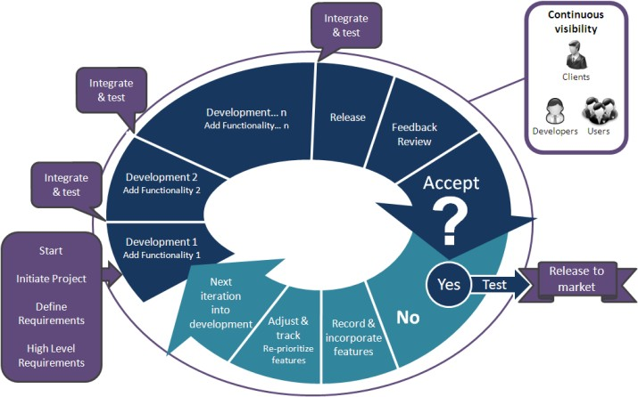
Fig. 1: Iteration Cycle of an Agile Project

4) Release phase that covers QA testing, training, documentation development and final release of the iteration into production; 5) Production phase which is about on-going support of the software, and 6) Retirement phase which includes end-of-life activities, including customer notification and migration. Please refer to Figure 2 for the agile software development cycle. (source: https:// www.smartsheet.com/understanding-agile-software-development-lifecycle-and-process-workflow)
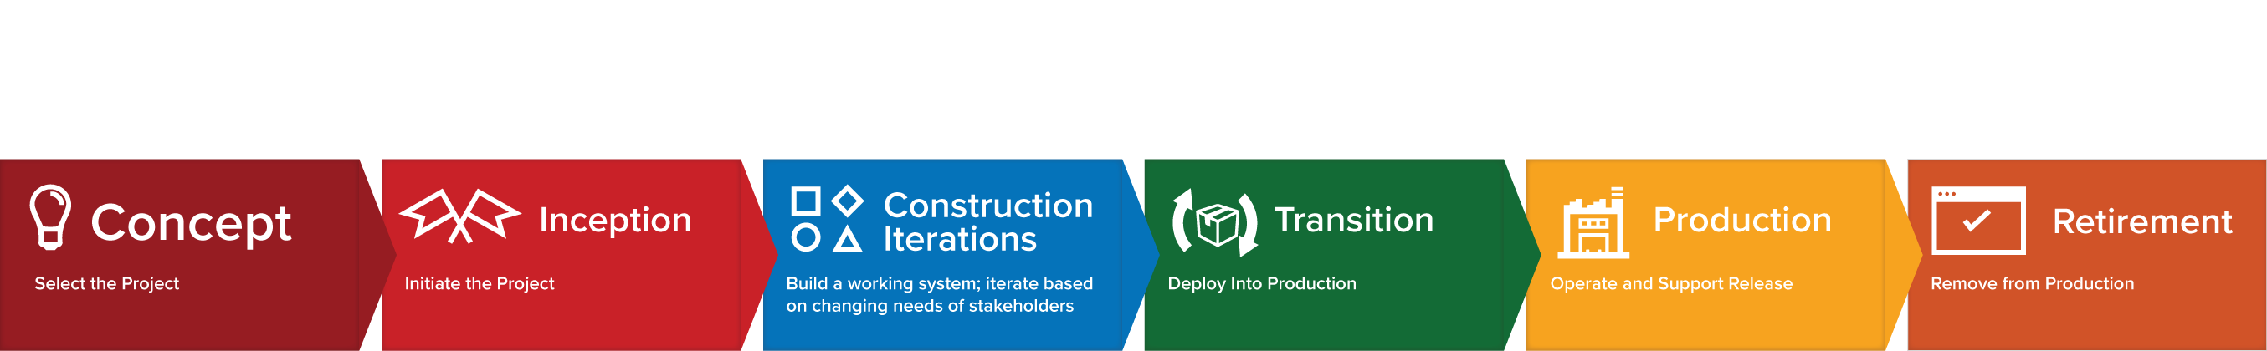
Fig. 2: Agile SDLC

During the Concept phase, the group research on a particular topic and looked for a company. For the second phase, the group defined the roles of each team and identified the stakeholders and the adviser. The group conducted several interviews with the department head, chief agriculturist and the Tarlac MDOs. The interviews were used to identify various IS-related problems and understand processes, policies and programs. The group then set the objectives of the project as well as the scope. An initial plan was made.
For every start of the iteration and construction phase/sprint, meetings with a researcher in the organization were set to check objectives are met. The meeting was also used for clarifications. After which, sprint planning was done to set objectives, targets and task allocation. We conducted weekly meetings with our adviser to see what suggestions or changes we needed to do. We conducted scrum meetings as a group to view progress and record accomplishments. Client approval was needed prior to proceeding to the next task. The last three phases were not performed except for testing since the scope of the project is up to working prototype only. Actual historical data was used in order to test the system. Please refer to section 3 for the discussion of the testing.
The researchers used Java, JavaScript, bootstrap, Highcharts, MySQL and for the project. The web tools used were based on the team’s prior knowledge. Android was the platform used to develop the mobile application for the farmers and MDO.

3. RESULTS AND DISCUSSION

Based on the data gathered, the main problem is difficulty of monitoring sugarcane production by the MDO and providing farmer assistance through programs and recommendation. The system has three modules: Data Acquisition Module, Crop Estimation Module, and Programs, Farmer Recommendation and Assistance Module. Refer to Figure 3 for the Conceptual Framework Diagram.
The data acquisition module focus on acquiring the needed data for analysis. For the mobile application, the farmer can plot the area of their farm using the map so that they can determine how much is the actual area they have harvested and is yet to be harvested. The farmers are also able to enter the amount of tons cane which they have given to the mills. The data sent by the farmer through mobile will update the weekly crop assessment. Refer to Figure 4 for the screen shots.
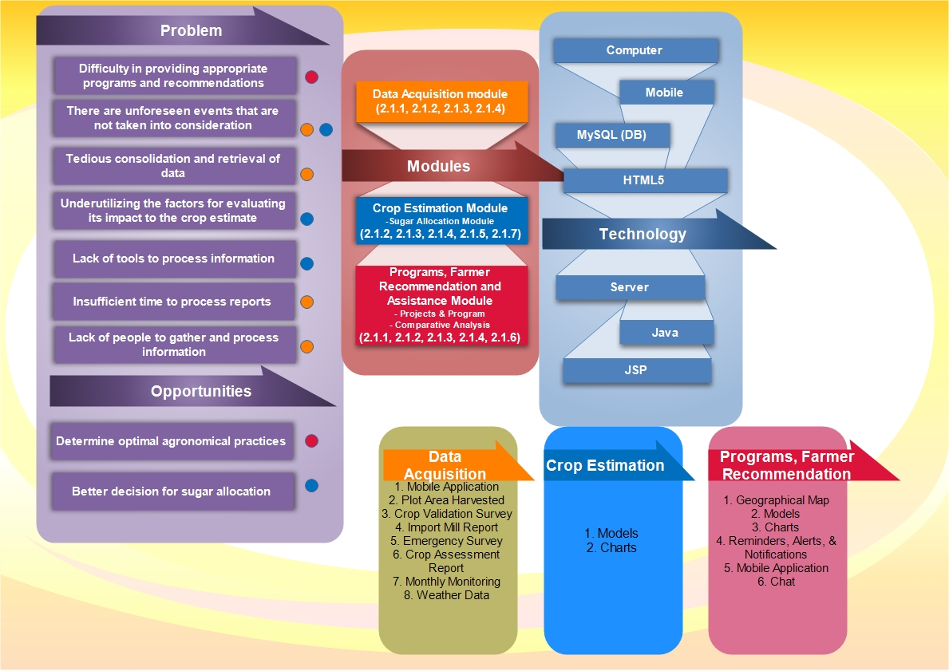
Fig. 3: Conceptual Framework

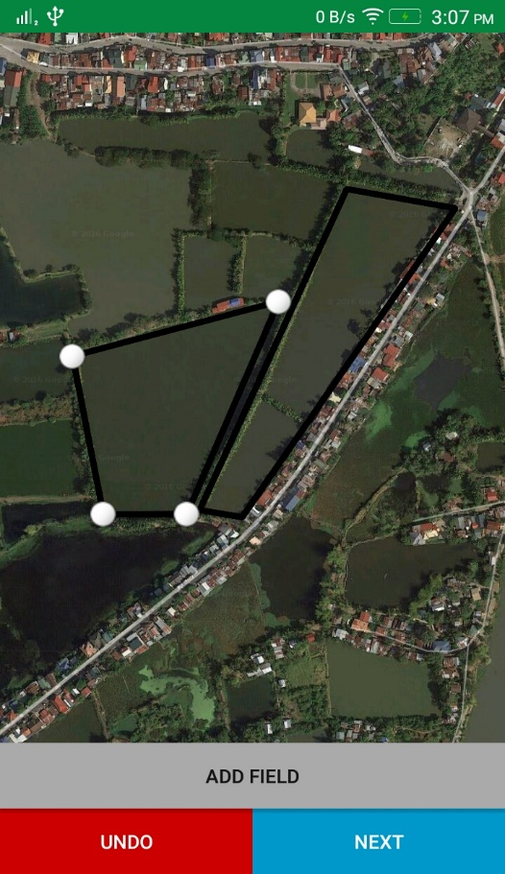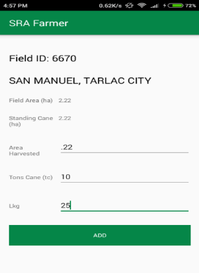
Fig. 4: Sample Screen Shots for Data Acquisition

The MDO also conducts a quarterly survey using the mobile application to update the farmer and farm profile. The profile contains the farmer’s basic information and the details of his farm/s. All of these data will be used by the MDO to create an observation and comparison in the farmer recommendation module.
For the Crop Estimate Module, the data to be used for calculating the initial estimate will be historical data which is from previous crop years. For the following quarters of the crop season, it will be adjusted on a weekly basis. The crop estimate and productivity will be based on the generated crop assessment reports, crop validation survey obtained from the data acquisition module, and other factors such as weather and agronomic factors (e.g. rainfall, tiller count and average temperature). Crop estimate will be determined by the use of predictive model/s that can help derive to an acceptable forecast. The estimate will be for determining the production for the next year. The model will not change, instead the parameters adjusts in reference to the historical data.
At least three (3) years’ worth of data from the previous years is going to be used. Historical data will be needed in order for the model to work and check the consistency of the model’s accuracy. The weather data to be used in the system during the actual operations are going to be gathered from PAG-ASA’s forecast (Data Acquisition Module). Soil analysis data can be gathered from the farmer’s profile. The MDO is able to generate his forecasts for validation purposes based on the actual production being input. The forecasts can be updated when there are damage reports. There, the area affected will be reduced to the total area and will reflect to the production. Simulations can be seen and are considered as tests. The MDO can then select the forecast which will reflect in the crop assessment report if the crop estimate is to be updated. For the MDO, he will be using tons cane for the forecast while the board member uses LKG. The weekly statistics report is displayed to the board members to help in making decisions for the nationwide sugar allocation. Refer to Figure 5 for the sample screen shots.
The MDO can send farming recommendations to the farmers like irrigation, drainage and cultivation. The recommendations are either ones that aims to solve a problem or ones that are for improvement. Recommendations that are for improvement have durations and can be modified. If the recommendation is aimed to solve a problem, the MDO will select the problem/s to be solved by that recommendation. The MDO can also create a new recommendation and can choose whether the recommendation will be aimed at solving a problem or for improvement. The details include the farm's productivity, farmer profile and agronomic practices used in each farm. These recommendations are sent by the MDO. These farm data are shown via the comparison page where the MDO can select different tags (e.g. area, barangay, etc.) to filter the farms with similar characteristics. There the MDO can create a comparison from the selected farms and see the differences and similarities. The MDO can also view the similar problems and recommendations that the similar farms have. Afterwards, the MDO can send recommendations or report problem for the farms he has selected in his comparison.

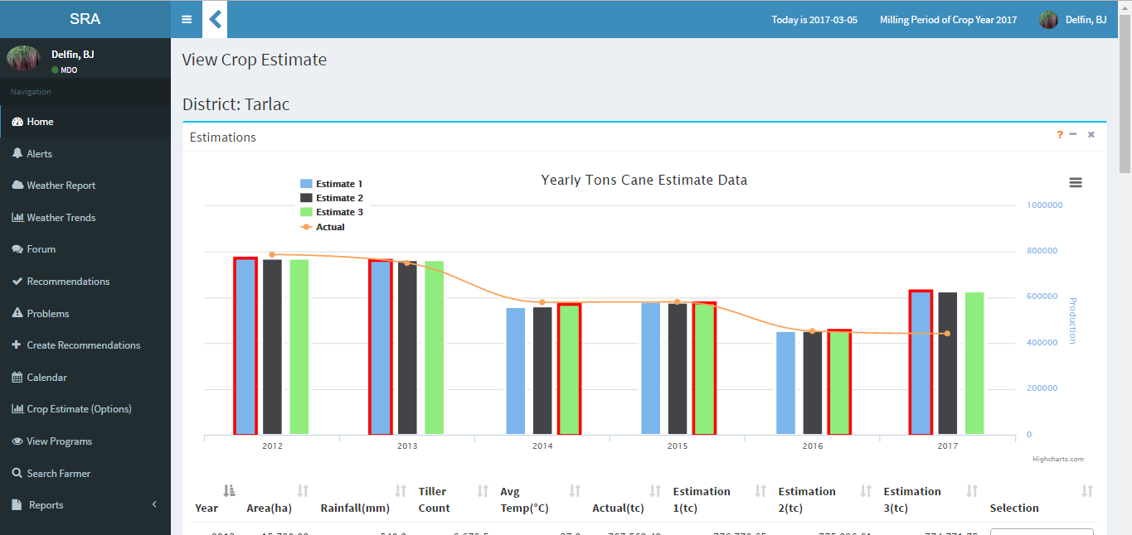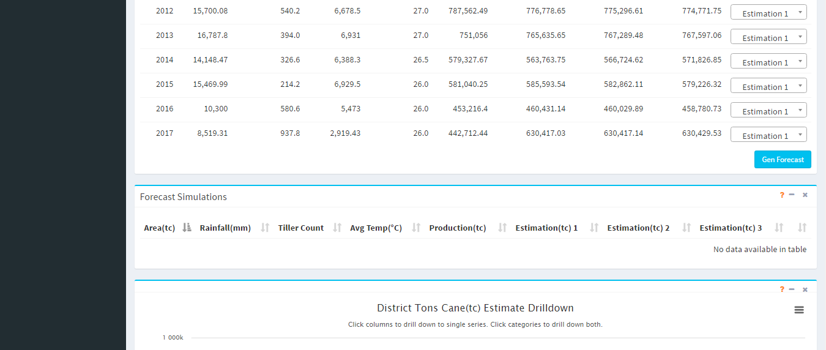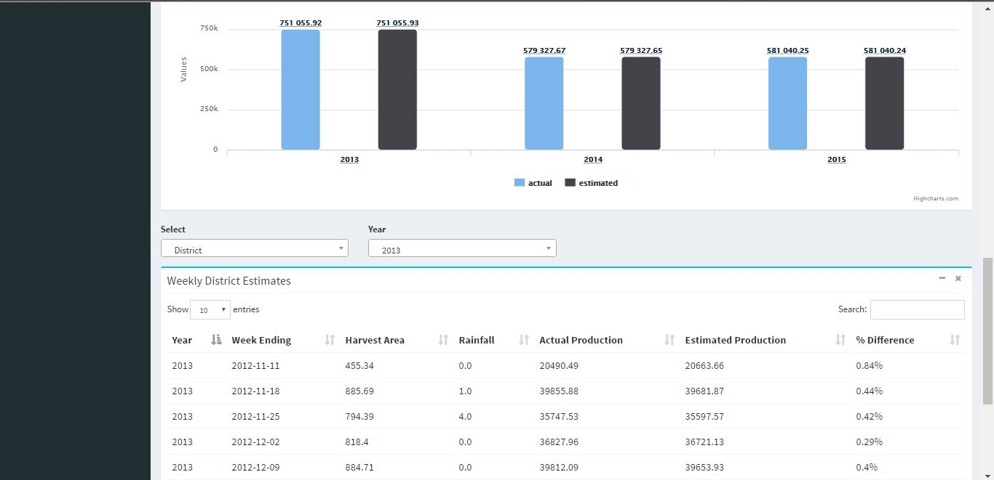
Fig. 5: Sample Screen Shots for the Crop Estimate
Another submodule consists of the programs and projects wherein the board members can see in the homepage the weekly production for the different regions nationwide as well as the ongoing programs. Refer to Figure 6 for the screen shot of the ongoing programs.
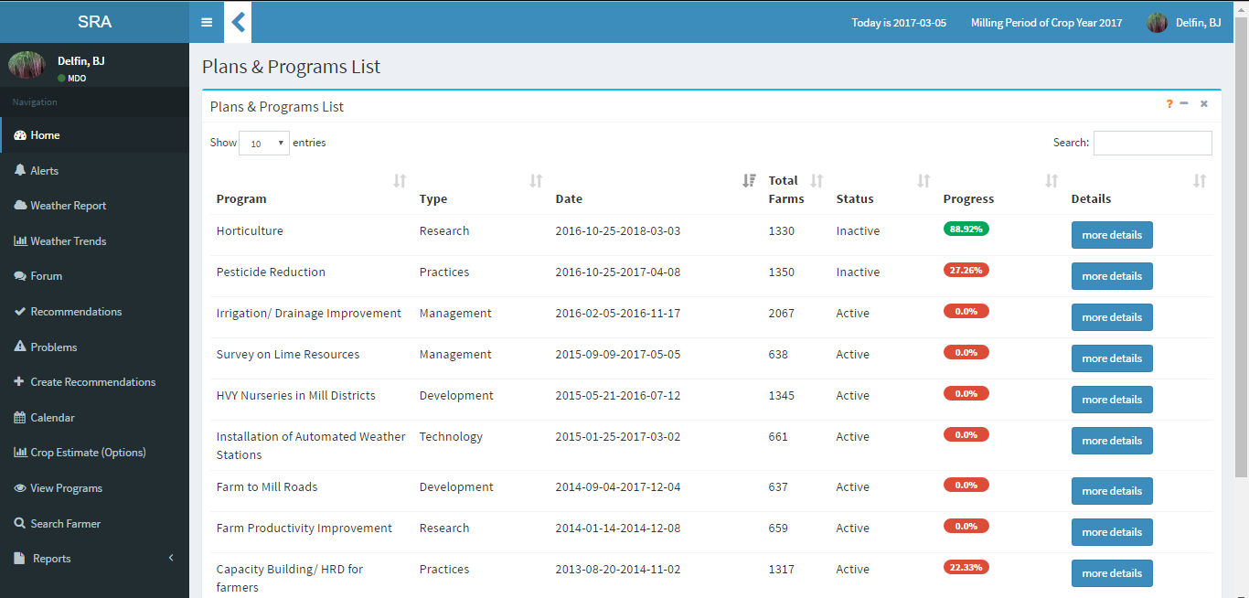
Fig. 6: Sample Screen Shot of Program List

In creating a program, the board members can select the type of program and the duration. The board member can also select the problems that the program will be aiming to solve. The progress can also be seen and is updated every time the performance indicator values are edited. The system would be able to record the difference and improvement in productivity from before, during and after the program has been implemented. Based on this, the board members could decide whether to keep the program or update it. Refer to Figure 7 for the screen shot.

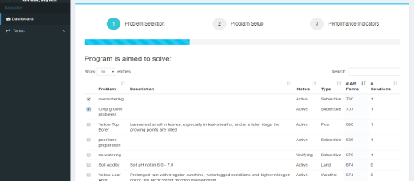
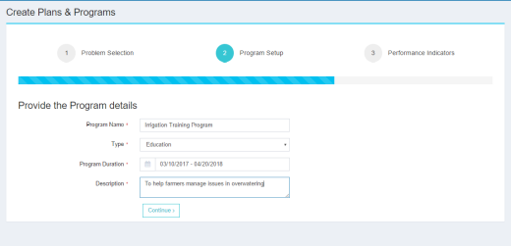
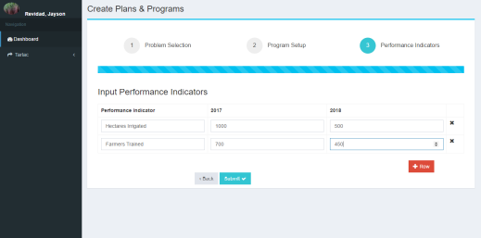
Fig. 7: Sample Screen Shot for Creating a Program

Another part would consist of assisting farmers. The mill district officer can send weather updates to the farmers and notifying if there would be a possible typhoon and that the MDO can also recommend the farmers to harvest the remaining crop. The farmer will be notified from the mobile application and can decide whether to harvest the crop if needed. The farmers can inquire to the MDO through the forum. He can ask for assistance from the mill district officer if the farmer does not clearly understand the farming practice that was recommended to them. The farmer can post problems and the MDO is the one to validate those posts. When posting, the farmer can take a picture as part of his proof that he has the problem. The MDO can send recommendations to the farmer from the forum and the farmer will be given a notification of that recommendation. He can also determine the problem based on the picture and details posted by the farmer. He can click yes or no to that recommendation to validate his response to the MDO’s message. When the MDO opens a post, he can either approve or reject the post. Refer to Figure 8 for the sample screen shots.

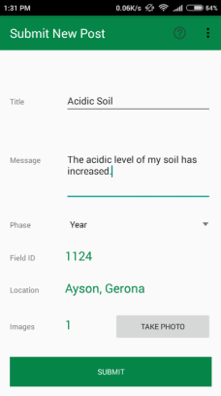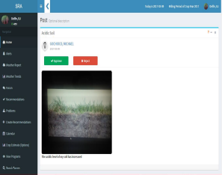
Fig. 8: Sample Screen Shot of Farmer Reporting a Problem

A user acceptance testing (UAT) was conducted among board members, MDO and farmers. The UAT focused on navigation, usability, functionalities and security. The range was from 1-5, with 5 being the highest. For the MDO UAT, the average was 4.8. For the board member, the average score was 4.7. For the farmers, the average was 4.2. They all agreed that the proposed system is very helpful for making their work faster. The user interface for them is also attractive. The functionalities are also helpful for them. Navigation was also easy for them. The color coding were also easy for them to understand. The farmers, however, had difficulty in understanding some information in the mobile application primarily because of the English Language. The farmer also had to adjust more to the mobile application as compared to the mill district officer.
According to the MDO, he would like to have the system implemented at least in his district because it would make his work easier and he could focus on research and helping the farmers. He would be able to handle and access large amounts of data more efficiently since it is consolidated and processed immediately upon submission. An example would be in the creation of farm observation and comparison. The data of each farm is properly consolidated and so it can be used to effectively identify problems and send appropriate recommendations. The farmers found the mobile application to be very interesting and convenient. They found the forum to be very useful for communicating with the MDO and other farmers. Their only concern was that the mobile application didn’t currently support their own dialect. The board members found the system to be very interesting and practical. They said that it can work in real life application. They would however like to have a complete business solution based on this system that would cover their other processes in the organization. Overall, the users of the system found the proposed system to be very valuable and effective.

4. CONCLUSIONS

The proposed system would greatly benefit SRA especially in their extension services to the farmers. It can help the MDO assist and monitor the farms within his district better. Communication between MDO and farmer will also improve with the use of the mobile application. The crop estimate is automated which can help the user evaluate different forecasts when they conduct their tests. Also, the farmers can report concerns and get immediate feedback through the mobile application. However, the mobile application can be further improved by using a language that the farmers can easily understand (e.g. Tagalog). The tool can also be applied in other types of plantation such as rice or corn and it can be further extended to farm cooperatives in terms of sharing information related to crop problems and possible solutions.

5. ACKNOWLEDGMENTS

The dproponents extend their deepest gratitude to SRA board members, MDO and farmers especially Mr. Laverne Olalia, Mr. Fernando Corpuz, Mr. Max Pelle and Ms. Natalie Tasis for allowing them to complete this project.

6. REFERENCES

Nace, S. (2015, July 15). Topic: Sugar Industry. Retrieved December 21, 2016, from http://www.statista.com/topics/1224/sugar/

Official Gazette (2015, March 12). Republic Act No. 10659. Retrieved December 21, 2016, from http://www.gov.ph/2015/03/27/republic-act-no-10659/

Raw Sugar Production by Month, Area Planted & Yield per Hectare 2011-2016 (n.d.). Retrieved May 15, 2017 from: http://www.sra.gov.ph/wp-content/uploads/downloads/2016/09/Raw-Sugar-Production-by-Month-Area-Planted-Yield-per-Hectare.pdf

What is Agile Methodology? and Why Do We Use It? (2016, March 14). Retrieved May 15, 2017, from http://vcwebdesign.com/uncategorized/what-agile-methodology-why-do-we-use-it/

Home. (n.d.). Retrieved May 15, 2017, from http://istqbexamcertification.com/what-is-agile-methodology-examples-when-to-use-it-advantages-and-disadvantages/

Understanding the Agile Software Development Lifecycle and Process Workflow. (2017, February 15). Retrieved May 16, 2017, from https://www.smartsheet.com/understanding-agile-software-development-lifecycle-and-process-workflow

